302 - Flight - Navigation

Navigate to an Emergency Locator Transmitter (ELT)
- On ARC-131 radio panel (COMM), set frequency to 40.05.
- Turn knob to HOME (homing)
- Set Sensitivity Switch (next to Course Deviation Indicator) to HIGH.
- Course Deviation Indicator will show direction of signal. You're flying toward it when the vertical line is aligned in the center.

Navigate to a beacon (FM Radio, NDB, VOR, ILS)
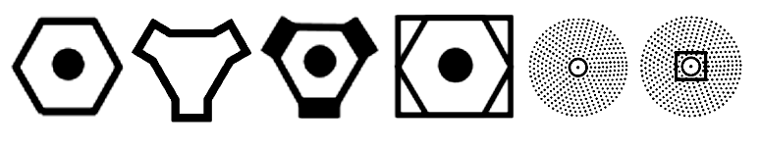 VOR TACAN VORTAC VOR-DME NDB NDB-DME
Homing to FM radio station
- On FM COMM panel (ARC-131 radio):
  - Mode knob ... HOME
  - Tune frequency with knobs.
- CDI gauge shows needles (looks like ILS needles) in the direction to the signal.
  - Make sure you're flying toward the signal (and not directly away) by turning away from the needle; it should move in the opposite direction you turned.
NDB
- On ADF radio panel (ARN-83 radio):
  - Gain Control / Mode knob ... ADF (left/right click to cycle modes)
  - Tune Control / Band Selection knob ... As needed (left/right click to change frequency range, scroll to tune frequency)
  - Watch the signal strength needle above: left = weak, right = strong
- Receiver NAV switch ... ON (row of switches above Intercom Mode knob)
- VOR/ADF knob on compass ... ADF
- Pointer on compass indicates direction to beacon.
VOR
- NAV-COMM radio power knob ... PWR (left/right click to cycle power mode)
  - Tune frequency by scrolling on knobs
- VOR/ADF knob on compass ... VOR
- Pointer on compass indicates direction to beacon.
- To fly a specific radial course to/from the VOR, set course with OBS knob on CDI (below compass). Needles on CDI show course deviation.
- TO/FROM triangle on lower right quadrant of CDI points up (TO) if flying on the selected course will take you toward the VOR; if the triangle points down (FROM), flying on the selected course will take you away from the VOR.. e.g. If you are on the 90 deg radial relative to a VOR, setting your CDI course to 270 will show TO, and setting your CDI course to 90 will show FROM.
ILS (click on runway icon to get window with ILS freq)
- Same as VOR, but set the course on the CDI to be the runway heading.

